NSS

NATIONAL SERVICE SCHEME

The National Service Scheme (NSS) is a central sector scheme of Govt. of India, Ministry of Youth Affairs and Sports. It provides opportunity to the student youth of 11th and12th class at schools at 12 board level and student youth of technical institution, Graduate and Post graduate at colleges and university level of India to take part in various government led community service programmes. The sole aim of the NSS is to provide hands on experience to young students in delivering community services.
It also provides the student opportunity to understand the community identify its needs and problems as well as the solutions in which they can be unvalued by assuming social and civic responsibilities. NSS enables students to participate in various programmes of Social service and National development and to help the community.

The broad objectives of NSS are to:-

1. Understand the community in which they work.
2. Understand themselves in relation to their community.
3. Identify the needs and problems of the community and involve them in problem
Clung process.
4. Gain skills in mobilizing community participation.
5. Acquire leadership qualities and democratic attitudes.
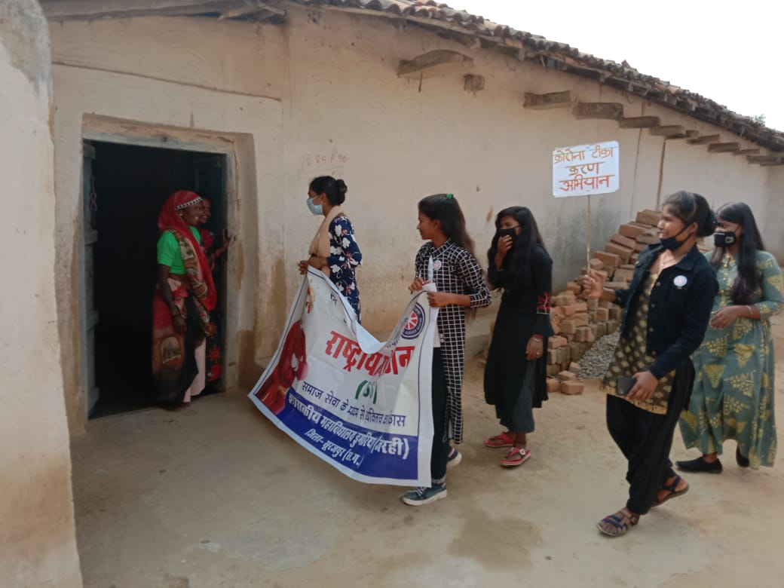
6. Develop capacity to meet emergencies and natural disasters.
